# Department of Computing

# CS 212: Object Oriented Programming

# Class: BSCS-8ABC

# Lab 9: Basic GUIs

# Date: April 15, 2019

# Instructor: Hirra Anwar

**Learning Objectives**

The learning objective of this lab is to understand and practice the concept of Graphical User Interfaces, various containers and components available in SWING and AWT, layout managers and their properties and basic action listeners.

Refer to GUI slides for details related to SWING hierarchies components containers and other concepts. Explore different properties using JAVA docs for components and containers and practice them in this lab.

**Activity #1**

Create the following GUI by using appropriate container and components to the GUI. Position the components using either the properties of components or layout manager.

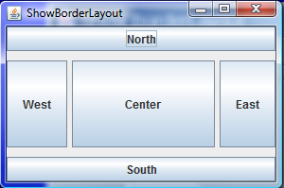

**Lab Task #1**

Write a computer program which displays the following GUI. Based on the number of times a button is clicked, the text box gets populated with that value. You need to add appropriate containers and components. Check the differences between different types of containers that are available and state why you chose a specific container.

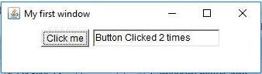

**Lab Task #2**

For this task, design and implement a Graphical user interface for a calculator application. Use one of the layout managers to build the GUI. In this task you need to create one class for GUI and implement all components in that class. You can create another test class as well to test the GUI components.

**Lab Task #3**

For the GUI created in task 2, implement action listener. When you click the buttons, some action (calculations) should take place.

[You do not need to implement the complete calculator application, however try creating a calculator as much as you can.]

**Deliverable**

Upload a single word file with code and screenshot of output on LMS.